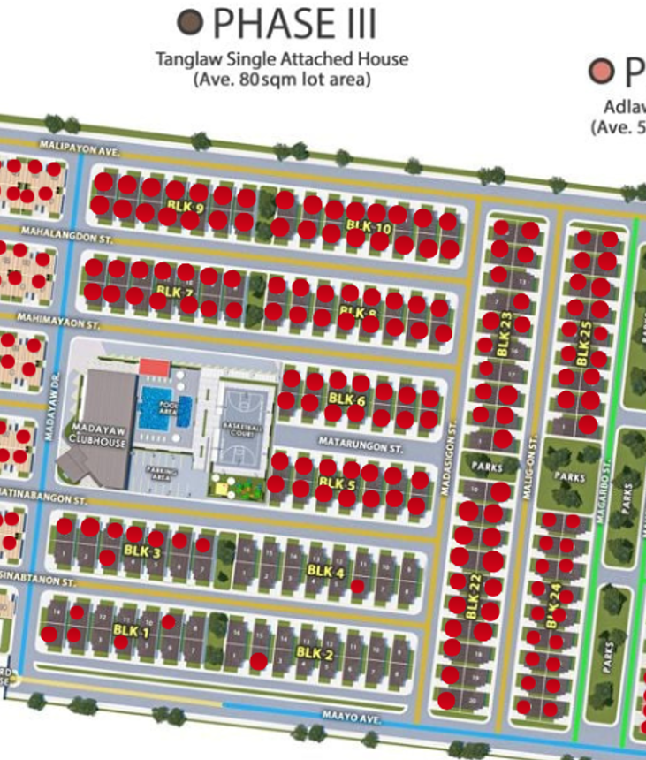
UPDATED AS OF JULY 3, 2026

